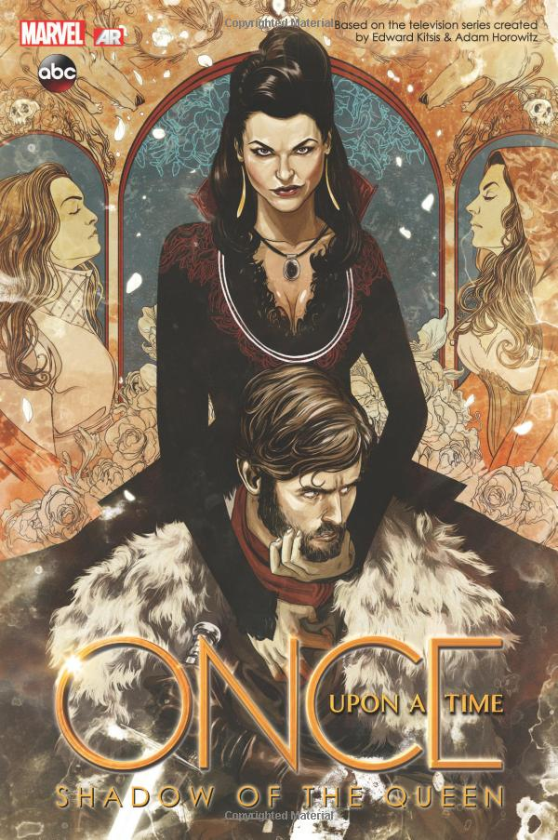

2016: Explain the visual element that has the greatest effect on your interpretation of this image.

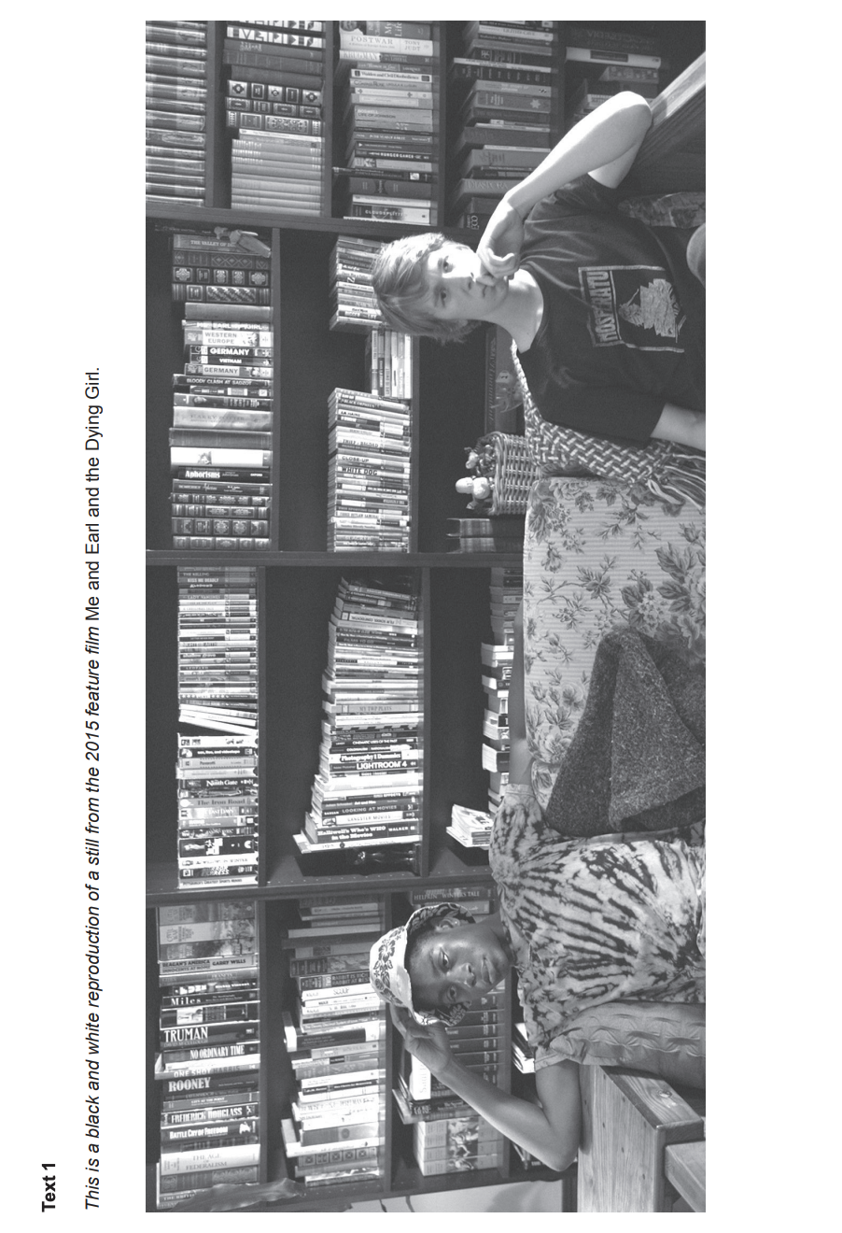

2017: Explain how your response to this image has been affected by the arrangement of visual elements within the frame.

This is a greyscale version of a photograph taken by Cecilia Wessels of Alberta, Canada of her husband, Theunis, mowing the lawn.



2018: Analyse how Text 1 works to convey an idea about human nature.

This is a greyscale version of the book cover of the 2018 novel, A Taxonomy\* of Love, by Rachael Allen.

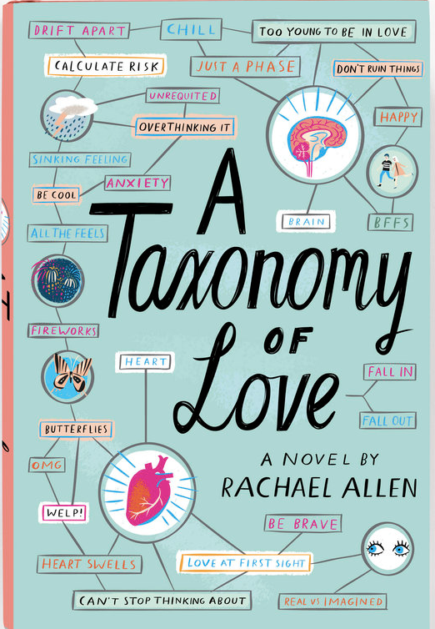

\*Taxonomy: a classification of something into ordered categories

2018: How does the multimodality of Text 3 influence your interpretation of it?

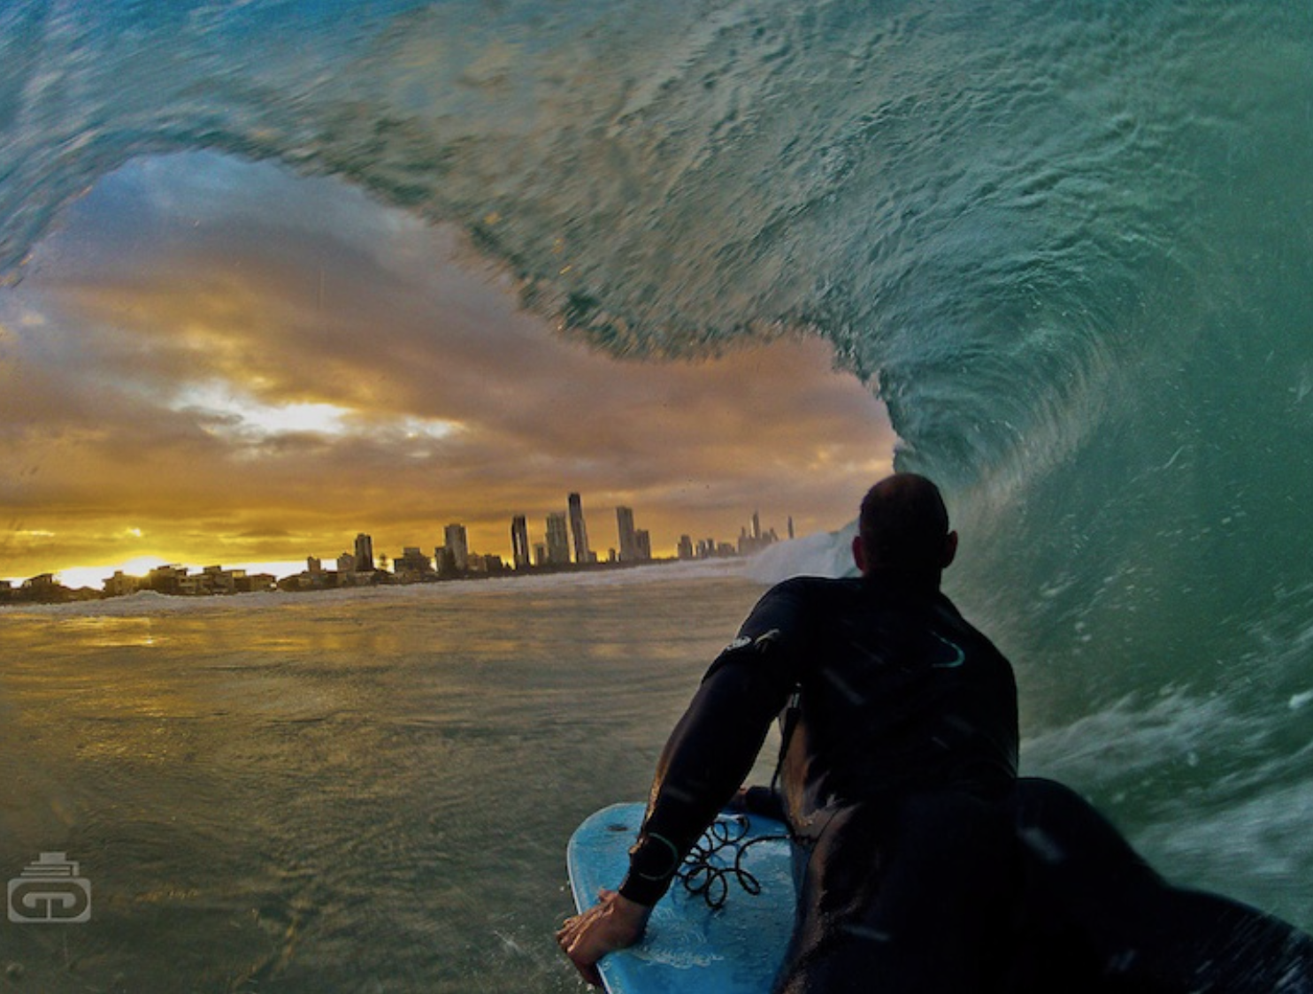

2019: Explain how three visual language features in this image engage you in the world of the bodyboarder.



Create your own question:

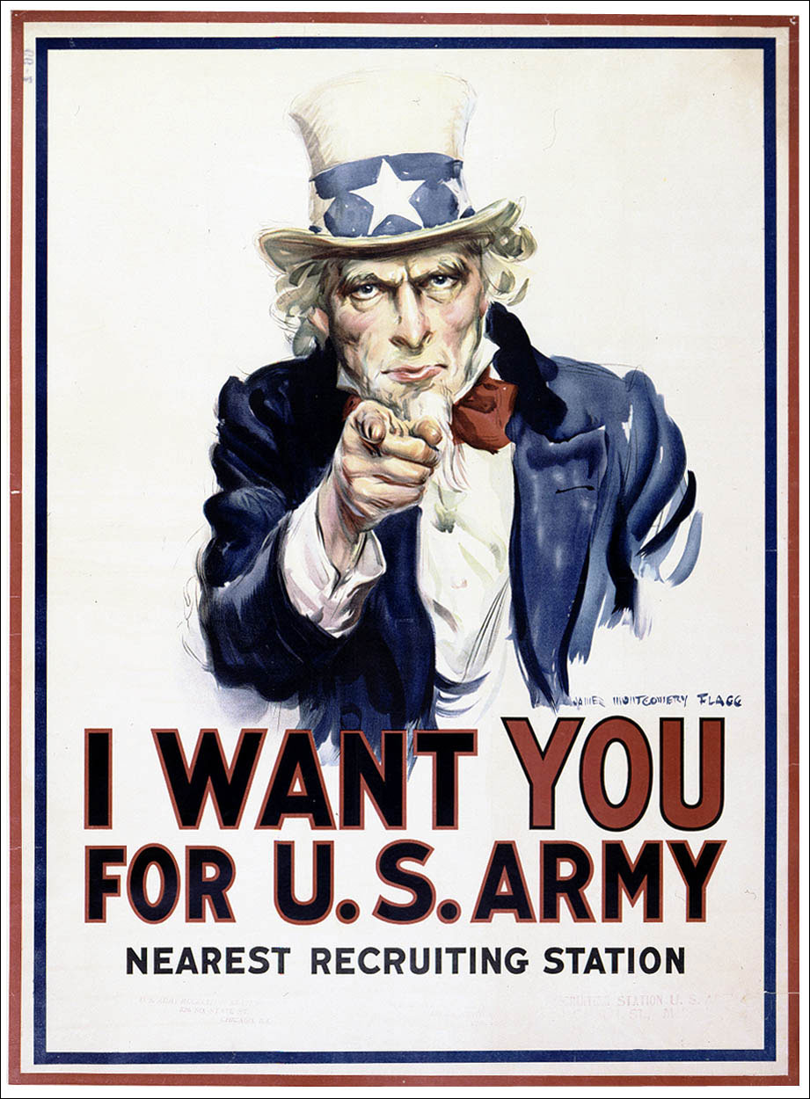

Explain how visual elements have been used for a particular purpose/ effect.